ASSIGNMENT-05/10/2026

Web Search Automation Using Selenium
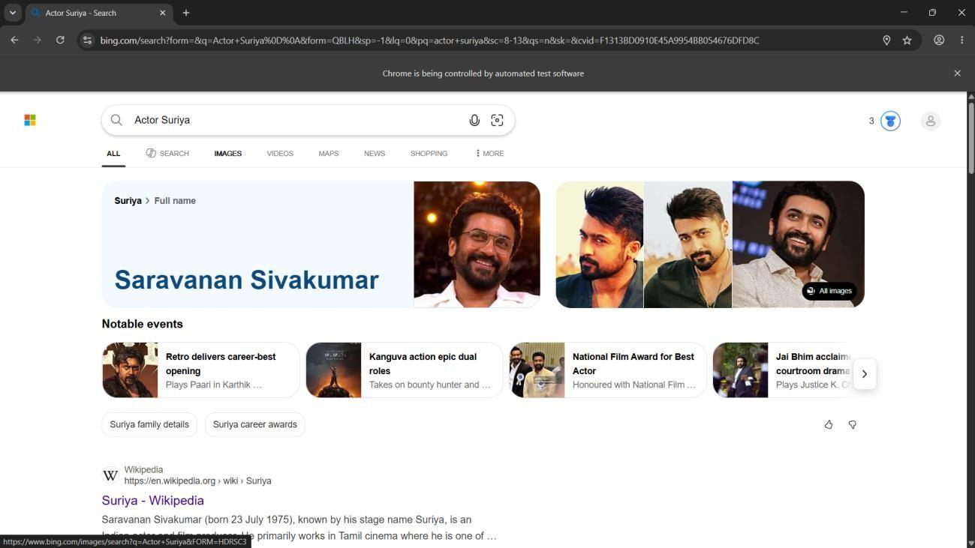

from selenium import webdriver
from selenium.webdriver.common.by import By from selenium.webdriver.common.keys import Keys import time

driver = webdriver.Chrome() driver.get("https://www.bing.com/") time.sleep(3)
search = driver.find_element(By.NAME, "q")

print("Search displayed:", search.is_displayed()) print("Search enabled:", search.is_enabled())

search.send_keys("Actor Suriya") search.send_keys(Keys.ENTER)

time.sleep(5)

input("Press Enter to close the browser...")
driver.quit()

Sauce Demo Login Automation Using Selenium
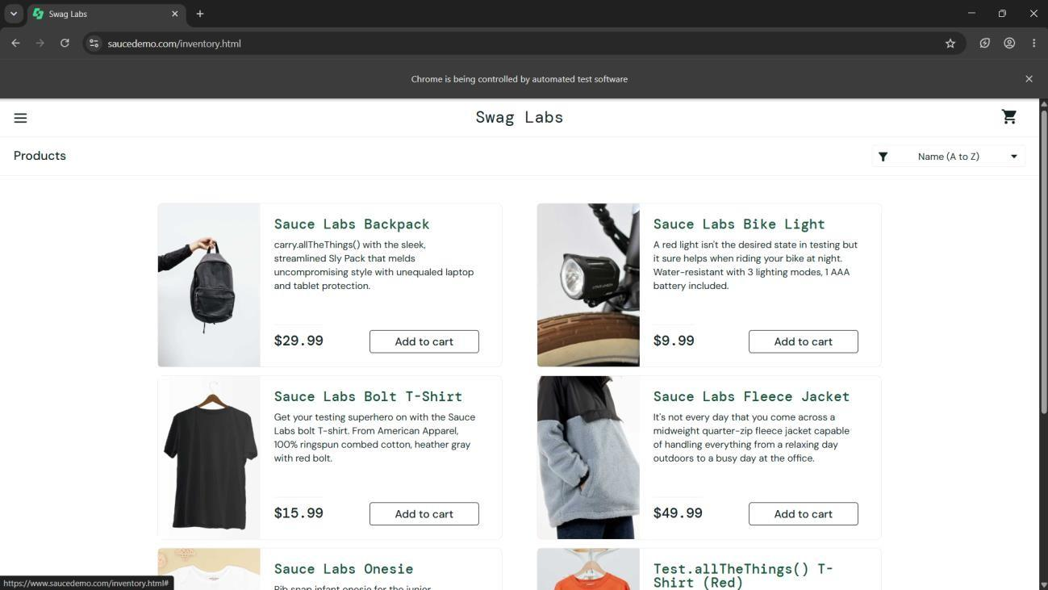

from selenium import webdriver
from selenium.webdriver.common.by import By driver = webdriver.Chrome() driver.get("https://www.saucedemo.com/")
username = driver.find_element(By.ID, "user-name") password = driver.find_element(By.NAME, "password") login = driver.find_element(By.ID, "login-button")

username.send_keys("standard_user") password.send_keys("secret_sauce")

print(username.get_attribute("placeholder")) print(login.is_enabled()) print(username.is_displayed())

login.click()
input("Press Enter to close the browser...")

driver.quit()

Flipkart Mobile Number Login Verification Using Selenium
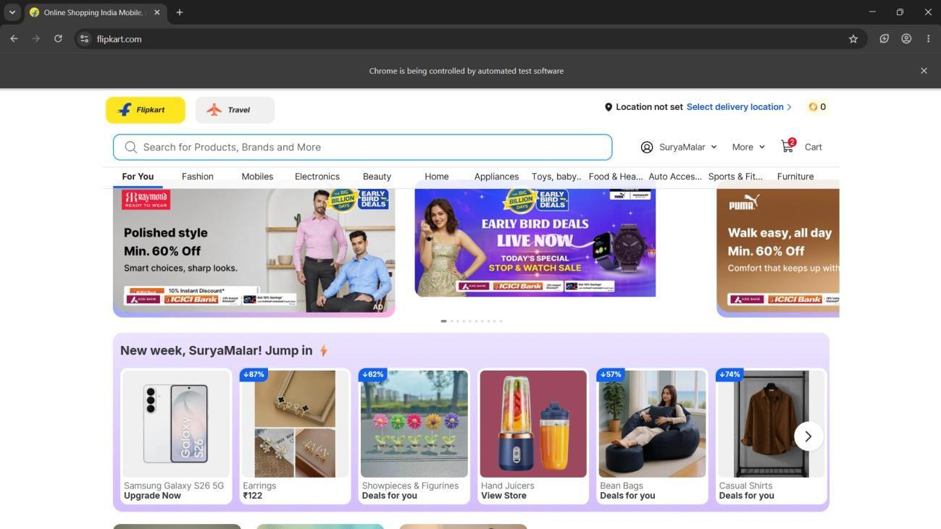

from selenium import webdriver
from selenium.webdriver.common.by import By import time
driver = webdriver.Chrome()
try:
driver.get("https://www.flipkart.com/")
driver.maximize_window()
time.sleep(5)
print("Flipkart opened successfully")
input("Browser is open. Press Enter to continue...")
# Click Login
login = driver.find_element( By.XPATH,
"//span[contains(text(),'Login')]"
)

login.click()
print("Login clicked")
time.sleep(3)
input("Login page opened. Press Enter to close...")
except Exception as e:
print("ERROR:")
print(e)
input("An error occurred. Press Enter to close the browser...")
finally:
driver.quit()

